
Pre-AP Biology
Unit 3 – Cellular Energetics
Suggested Duration: 11 Days

CELLULAR ENERGETICS
UNIT PLAN

Table of Contents
UNIT NARRATIVE 1
CONTENT STANDARDS 2
UNDERSTANDINGS AND QUESTIONS 2
ROADMAP 3
UNPACKED STANDARDS 12
VOCABULARY GLOSSARY 16

UNIT NARRATIVE
Cellular energetics involves learning concepts centered around the concept of energy. The first major concept that is studied is that of enzymes. Enzymes lower the activation energy of certain chemical reactions and thus allow for energy to either be released or stored. Students experience the first lesson involving the structure and function of these enzymes and then apply this learning in the 2nd lesson (Gizmo activity). The students will cap off their learning of enzymes by participating in a hands-on-minds-on lab where they investigate different factors that affect enzyme activity. Students will transition to learning associated with cellular respiration, where energy is gleaned from glucose molecules (producing ATP). Students model the process and then experience a lab where they investigate different factors that might cause cellular respiration to cease to work correctly. Students then transition to learning associated with photosynthesis, where energy is stored up in the form of glucose. Students model the process and experience a lab where they investigate different factors that might cause photosynthesis to cease to work properly. Finally, students use models to compare and contrast both cellular respiration and photosynthesis.

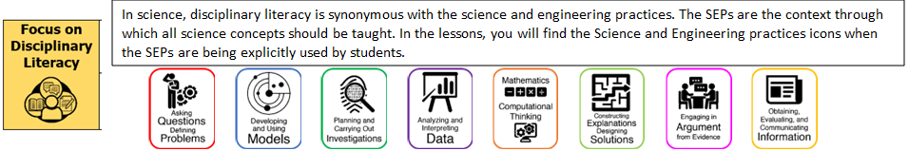

CONTENT STANDARDS
Below are the standards taught and assessed in this unit.
Learning Objectives (Students will be able to…)
Cellular Energetics
B.11.A – explain how matter is conserved, and energy is transferred during photosynthesis and cellular respiration using models, including the chemical equations for these processes.
B.11.B – investigate and explain the role of enzymes in facilitating cellular processes

UNDERSTANDINGS AND QUESTIONS
Important big ideas and processes for the unit.
Enduring Understandings
- Biological systems have specialized structures that enable specific functions necessary to sustain life.
- Chemical reactions regarding the four biological molecules are an essential part of life.
- All living things are the outcome of many chemical reactions happening every second of their lives.
- All living things depend on enzymes that act as catalysts to speed up these reactions.
- Enzymes are protein molecules whose shape (structure) is critical to their function.
- Various environmental factors can damage the functional shape of enzymes rendering them useless, possibly with catastrophic results for living things.
- Nearly all living things perform cellular respiration reactions that break down biomolecules to convert stored energy into the usable form of energy for all of life which is ATP.
- These reactions can occur with oxygen (aerobic) and in some organisms without oxygen (anaerobic).
- Aerobic reactions convert more energy than anaerobic reactions and can lead to muscle fatigue when reactions run in low oxygen situations.
- Plants, green algae, and some bacteria convert light energy into chemical energy in the chemical reactions of photosynthesis.
- Plants need light energy, the green pigment chlorophyll, carbon dioxide and water as reactants and produce oxygen and biomolecules as products of the photosynthetic reactions.
- The chemical energy that is converted during photosynthesis is stored in the bonds of the biomolecules that are produced.
- ATP is the molecule of energy for most of the living world.
Key Questions
- What biological molecule is an enzyme?
- How do enzymes speed up chemical reactions?
- How does the structure of an enzyme all for it to only catalyze certain chemical reactions?
- How do living things attain usable energy from glucose?
- How does glucose break down differently in a high concentration of oxygen (aerobically) and a low concentration of oxygen (anaerobically)?
- What factors affect the rate of cellular respiration?
- What are the reactants and products of the cellular respiration reaction?
- What are the reactants and products of photosynthetic reactions?
- What factors affect the rate of photosynthesis?
- What occurs during the light reactions of photosynthesis?
- What occurs during the light independent reactions of photosynthesis?
ROADMAP
Suggested daily guide for instruction in this unit.

Lesson #1: Enzyme Structure and Function |  | Date:
Objective  SWBAT: Model an enzymatic reaction and explain why the structure of the enzyme is crucial to its function.  Standards  B.11.B – Investigate and explain the role of enzymes in facilitating cellular processes.  Vocabulary  Enzyme  Activation energy  Substrate  Active site  Competitive inhibition  Non-competitive inhibition  Reactant  product  Science Practices/Prerequisite Knowledge/Skills  - Develop and Use Models  - Engage in Argument from Evidence  - Analyze and Interpret Data  - Cell structure/function | Instructional Notes  Students will participate in a Read to Learn activity that covers components of an enzymatic reaction, mechanism of that reaction, types of enzymes, and importance of enzymes in biological systems.  Then students will participate in a modeling activity using pool noodle enzyme models. Students will model how the enzyme connects to the substrate to become the enzyme-substrate complex which then catalyzes the reaction turning reactants into products. They will then model what happens to this reaction in the presence of competitive and non-competitive inhibitors.  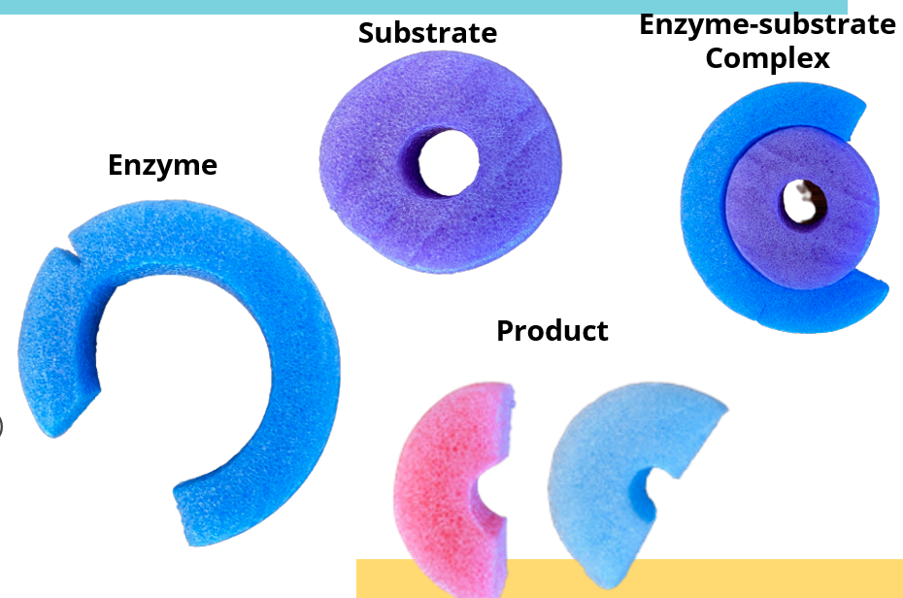  Students will then participate in a performance task called Cellulase. Students differentiate between the roles various macromolecules play in supporting cellular systems and demonstrate understanding of enzyme activity as they engage in model-based explanations. Finally, students illustrate their knowledge of experimental design as they analyze data and elaborate on further steps in a study on what influences cellulase reaction rates. |  | Lesson Look Fors  Look for teachers to:  - Allow students to productively struggle with the content, using accountable talk moves to facilitate the lesson.  - Teachers should be walking around the room ensuring that students are engaged in all activities correctly, consistently monitoring for incorrect biology.  Look for students to:  - Engage in the hands-on-minds-on modeling activity.  - Ask clarifying questions regarding what they are learning.  - Write in complete sentences.  Students Do and Know
   | - Model an enzymatic reaction.  - Analyze a scenario to predict an outcome.  - Annotate a reading passage to better understand concepts.
   | - An enzyme is a protein.  - Enzymes speed up chemical reactions by lowering activation energy.  - An enzyme has an active site where the substrate is able to fit.  - Inhibitors act to eliminate an enzyme’s ability to catalyze a reaction.
Materials Needed
- Prepare models

Lesson #2: Gizmo Lab – Enzyme STEM Case |  | Date:
Objective  SWBAT: Investigate the structure/function of enzymes and predict the cause of illness due to enzyme deficiencies.  Standards  B.11.B – Investigate and explain the role of enzymes in facilitating cellular processes.  Vocabulary  Enzyme  chemical reactions  substrate  reactant  product  reactional rate  catabolism  catalysis  denaturation  Science Practices/Prerequisite Knowledge/Skills  - Develop and Use Models  - Engage in Argument from Evidence  - Analyze and Interpret Data  - Cell structure/function | Instructional Notes  Students will participate in a Gizmos STEM Case involving a real-world application of enzymes. At the start of the case study students are introduced to their patient, Claire. Claire is a Great Dane who is experiencing rapid weight loss and lethargy even though she is eating a lot.    Working as a veterinary technician, students must examine Claire to determine the cause of her weight loss. Students then enter the Enzymes Handbook to learn the concepts they will need to solve the case and help Claire. The Handbook is an interactive guide that covers the key principles of enzymes. While in the Handbook students interact with a variety of scenarios each covering a different topic in enzymes. They also create and analyze graphs to prepare them to analyze Claire’s lab results. Once the Handbook is complete, students return to the case to collect data on Claire. They travel inside Claire’s stomach and small intestine to collect samples and take a closer look at pepsin, protease, carbohydrase, and lipase. Next, they compare Claire’s samples to those of a healthy dog (a control) to discover if the problem is in her stomach or intestine. From there they research three possible causes: enzyme active site mutation, abnormal pH, or low enzyme production. Students then hypothesize which problem Claire is experiencing and perform an experiment for each possible cause. At the conclusion of the case, students write a case summary to communicate their findings and practice scientific writing skills. |  | Lesson Look Fors  Look for teachers to:  - Teachers should be walking around the room during the Gizmo activity asking probing questions.  - Allow students to productively struggle with the content, using accountable talk moves to facilitate the lesson.  Look for students to:  - Engage in the online simulation and fill out the student document.  - Ask clarification questions regarding what they are learning.  - Writing in complete sentences  Students Do and Know
  - Interact with online case study and answer questions regarding the concepts learned.
  - Investigate a hypothesis using quality experimental design.
  - Make conclusions based on data analysis.
  - Denaturation involves an environmental factor causing a structure change in an enzyme that causes the function to change.
  - Enzymes are proteins.
  - Metabolism is the sum total of all chemical reactions inside the body, and they are often “run” by enzymes.
  - Enzymes increase the reaction rate of chemical reactions.
  - In a chemical reaction, reactants are converted into products.
Materials Needed
- Copies of the student handout
Lesson #3: Toothpickase Lab |  | Date:
Objective  SWBAT: Model the effects of environmental factors on the enzymatic rate of toothpickase.  Standards  B.11.B – Investigate and explain the role of enzymes in facilitating cellular processes.  Vocabulary  Enzyme  Chemical reaction  Substrate  Reactant  Product  Reaction rate  Kinetics  pH  substrate concentration  temperature  Science Practices/Prerequisite Knowledge/Skills  - Using Mathematics  - Engage in argument from evidence including dialogue  - Developing and using models  - Planning and carrying out investigations  - Cell structure/function | Instructional Notes  Background: Enzymes work to speed up biological reactions by lowering their activation energy. There are certain conditions that must be met for an enzyme to work efficiently: substrate concentration, temperature, and pH.  Task: The objective is to observe the effects of different substrate and enzyme concentrations on toothpickase and to determine the rate of enzyme activity of toothpickase. The toothpicks will represent the substrate and the students’ thumb and index finger represent the active site of the enzyme toothpickase. To catalyze the reaction (breaking the toothpick completely in half) students may only use one hand. Toothpicks not broken completely in half do not count as products.  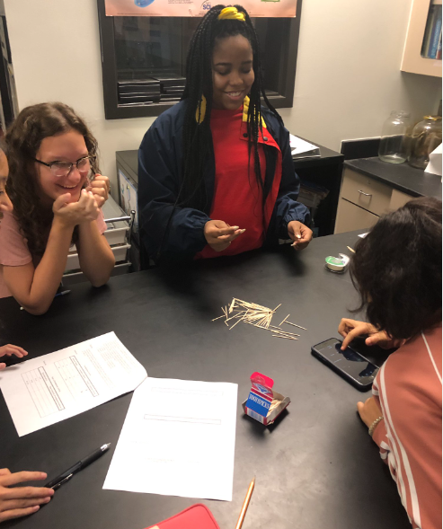 |  | Lesson Look Fors  Look for teachers to:  - Allow students to productively struggle with the content, using accountable talk moves to facilitate the lesson.  - Teachers should be walking around the room ensuring that students are engaged in all activities correctly, consistently monitoring for incorrect biology.  Look for students to:  - Engage in the hands-on-minds-on modeling activity  - Ask clarifying questions regarding what they are learning  - Write in complete sentences  Students Do and Know
  - Perform an experiment to test the factors that affect catalysis rates.
  - Use CER to defend their results.
  - Calculate rate
  - Enzymes function in specific environmental conditions.
  - Factors that affect enzyme rates are enzyme and substrate concentration, temperature, pH, etc.
Materials Needed
- Toothpicks
- Timers
- Ice
- Tape
- Paper plates

Lesson #4: Cellular Respiration Modeling |  | Date:
Objective  SWBAT: Create a model that shows the relationships involved in the process of cellular respiration.  Standards  B.11A Explain how matter is conserved, and energy is transferred during photosynthesis and cellular respiration using models, including the chemical equations for these processes.  Vocabulary  Cell respiration  ATP  mitochondria  aerobic respiration  anaerobic respiration  Science Practices/Prerequisite Knowledge/Skills  - Developing and using models  - Analyzing and interpreting data  - Cell structure/function | Instructional Notes  Students watch a video on cellular respiration (aerobic vs anaerobic) while answering questions on the guided notes.  Then students will participate in a card sort. It is imperative that you allow students to produce their own models, i.e., there are multiple ways in which students can find relationships among the different cards. The important thing is that they create their own models of how they fit together and then be able to communicate to others why they created the models that they did. You will need to cut these cards out before class and have them ready for each student (or student group).  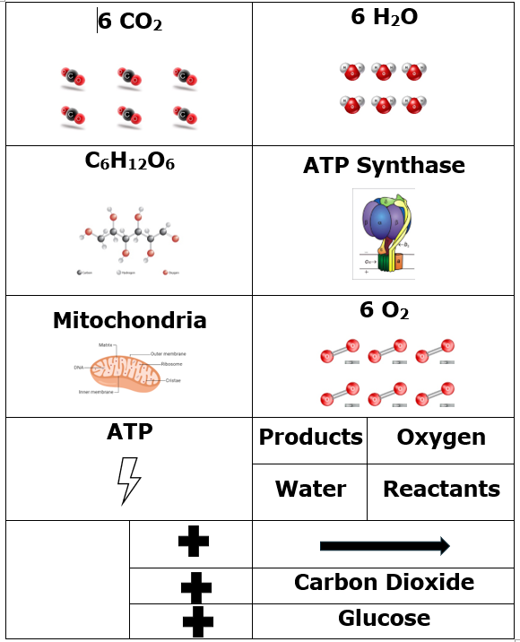  Then, students will have an opportunity to apply what they have learned by crafting a written response involving the purpose/process of cellular respiration, as well as analyzing a graph.  - For the graphical analysis, it is vitally important to call out that ATP is a PRODUCT of the reaction. The reaction of cell respiration drives the production of ATP – carbon dioxide is a byproduct and is released as a gas through the process of cell respiration. You may also inquire about what may happen to the athlete if oxygen is not present (anaerobic respiration, production of lactic acid). |  | Lesson Look Fors  Look for teachers to:  - Allow students to productively struggle with the content, using accountable talk moves to facilitate the lesson.  - Teachers should be allowing students to create their OWN interpretation on the card sort, supporting where appropriate.  - Teachers should be walking around the room ensuring that students are engaged in all activities correctly, consistently monitoring for incorrect biology.  Look for students to:  - Engage in the hands-on-minds-on modeling activity  - Ask clarifying questions regarding what they are learning  - Write in complete sentences  Students Do and Know
  - Create models of cellular respiration concepts.
  - Write a narrative based on the purpose/process of cellular respiration.
  - Analyze real-life graphical data in order to predict the process occurring.
  - Cellular respiration is glucose + oxygen à carbon dioxide + water + energy (ATP)
  - Aerobic respiration occurs in the presence of oxygen.
  - Anaerobic respiration occurs in the absence of oxygen.
  - ATP is the energy molecule utilized by most life forms.
Materials Needed
- Computer with internet access
- Copies of card sort in baggies

Lesson #5: Gizmo Lab – Cellular Respiration |  | Date:
Objective  SWBAT: Investigate a scenario to predict which step of cellular respiration is being affected.  Standards  B.11A Explain how matter is conserved, and energy is transferred during photosynthesis and cellular respiration using models, including the chemical equations for these processes.  Vocabulary  mitochondria  ATP  ATP synthase  cell respiration  aerobic respiration  anaerobic respiration  Science Practices/Prerequisite Knowledge/Skills  - Carrying out scientific investigations  - Analyzing and interpreting data  - Cell structure and function | Instructional Notes  Lesson Summary: At the start of the case, students are given the role of a medical toxicologist and are told that a CIA agent has been poisoned by a criminal gang. They then watch a video of Navy SEALs rescuing the agent (note that this video shows Navy SEALs carrying guns, but no graphic violence is shown). They learn that the agent’s symptoms are consistent with him being poisoned by something that is affecting cell respiration. They then enter the cell respiration Handbook to learn the science concepts they will need to identify the poison and save the life of the agent.  In the Handbook, students learn about chemical energy and that cell respiration occurs in the mitochondria of cells. The inputs and outputs of cell respiration are reviewed, which leads into brief overviews of the 4 steps of cell respiration, namely  - Glycolysis,  - Krebs Cycle  - The Electron Transport Chain (ETC)  - ATP Synthase  Students complete assessments to help them connect the 4 steps to the concentrations of pyruvate, NADH and hydrogen ions (H⁺). Note that detailed biochemistry is not included as the focus is on helping students spot patterns in the data needed to solve the case.  Upon completing the Handbook, students are presented with 4 possible poisons, each of which inhibits one of the steps in cell respiration. They then collect data from muscle cells of the agent on the concentrations of pyruvate, NADH and H+. Using their learning from the Handbook, students are asked to form a hypothesis as to which poison has been used. They then perform experiments with each poison and are able to revise their hypothesis as they collect more data and then apply the appropriate antidote. Finally, students write a case summary to report their findings and practice scientific writing skills. |  | Lesson Look Fors  Look for teachers to:  - Teachers should be walking around the room during the Gizmo activity asking probing questions.  - Allow students to productively struggle with the content, using accountable talk moves to facilitate the lesson.  Look for students to:  - Engage in the online simulation and fill out the student document.  - Ask clarification questions regarding what they are learning.  - Writing in complete sentences  Students Do and Know
  - Interact with online case study and answer questions regarding the concepts learned.
  - Investigate a hypothesis using quality experimental design.
  - Make conclusions based on data analysis.
  - Glycolysis is the splitting of glucose into 2 pyruvate, giving off 2 ATP.
  - The Kreb’s Cycle (Citric Acid Cycle) takes the pyruvate and gives off carbon dioxide, hydrogen ions, and 2 ATP.
  - The electron transport chain, where ATP synthase is, creates the most ATP (~32).
Materials Needed
Computers with internet access

Lesson #6: Photosynthesis Modeling |  | Date:
Objective  SWBAT: Create a model of photosynthesis and use this knowledge to predict the cause of three graphical scenarios.  Standards  B.11A Explain how matter is conserved, and energy is transferred during photosynthesis and cellular respiration using models, including the chemical equations for these processes.  Vocabulary  Photosynthesis Thylakoid  NADPH Lumen  ATP Thylakoid membrane  ADP Outer membrane  NADP+ Calvin Cycle  Chloroplast Light dependent rxns  Stroma  Science Practices  - Developing and using models  - Analyzing and interpreting data  - Producers make their own food using light, carbon dioxide, and water | Instructional Notes  Activity #1: Then students will participate in a card sort where they model the process of photosynthesis. It is imperative that you allow students to produce their own models, i.e., there are multiple ways in which students can find relationships among the different cards. The important thing is that they create their own models of how they fit together and then be able to communicate to others why they created the models that they did. You will need to cut these cards out before class and have them ready for each student (or student group).  Activity 2: Students watch a video on the photosynthetic process, while filling out guided notes.  Activity 3: The students use their guided notes to then make changes to their model according to what they learned in the video. Each group will then go look at another group’s model and compare their model to the other group’s model.  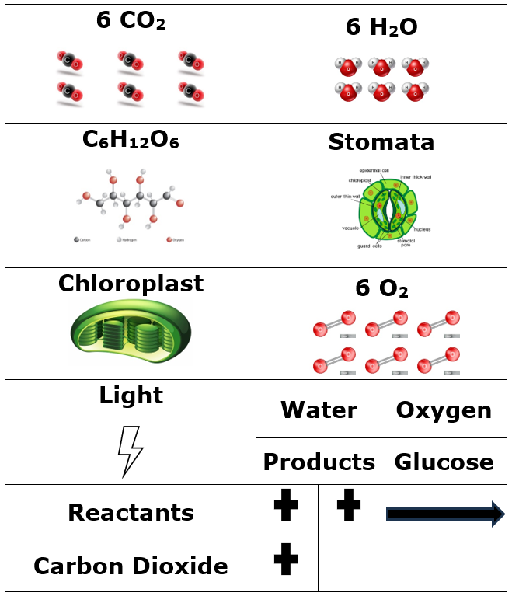 |  | Lesson Look Fors  Look for teachers to:  - Allow students to productively struggle with the content, using accountable talk moves to facilitate the lesson.  - Teachers should be walking around the room ensuring that students are engaged in all activities correctly, consistently monitoring for incorrect biology.  Look for students to:  - Engage in the hands-on-minds-on modeling activity  - Ask clarifying questions regarding what they are learning  - Write in complete sentences  Students Do and Know
  - Model the steps of photosynthesis.
  - Write a narrative of the photosynthetic process.
  - Analyze graphs in order to predict the cause of the data.
  - There are two phases of photosynthesis: light dependent and light independent (Calvin Cycle).
  - Photosynthesis occurs in the chloroplast.
  - Photosynthesis is carbon dioxide + water + light energy à glucose + oxygen.
  - The light dependent reactions occur in the thylakoid.
  - The light independent reactions occur in the stroma.
  - ATP and NADPH are energy-rich molecules that power the Calvin Cycle.
Materials Needed
- Computer with internet access

Lesson #7: Elodea Lab – Photosynthesis |  | Date:
Objective  SWBAT: Investigate different factors that affect the rate of photosynthesis.  Standards  B.11A Explain how matter is conserved, and energy is transferred during photosynthesis and cellular respiration using models, including the chemical equations for these processes.  Vocabulary  Photosynthesis Calvin Cycle  Limiting factor Chlorophyll  Photosystem I and II Carbon dioxide  Thylakoid Oxygen  ATP Wavelength  NADPH Glucose  Science Practices/Prerequisite Knowledge/Skills  - Developing and using models  - Analyzing and interpreting data  - Producers make their own food using light, carbon dioxide, and water | Instructional Notes  Teachers will have the option of doing either the Elodea Photosynthesis Lab or the Gizmo Photosynthesis Lab.  Elodea Lab  Students learn a simple technique for quantifying the amount of photosynthesis that occurs in a given period of time, using a common water plant (Elodea). They use this technique to compare the amounts of photosynthesis that occur under conditions of low and high light levels. Before they begin the experiment, however, students must produce a well-worded hypothesis to be tested. After running the experiment, students pool their data to get a large sample size, determine the measures of central tendency of the class data, and then graph and interpret the results.  Gizmo Photosynthesis Lab  In the process of photosynthesis, plants use light energy to combine carbon dioxide and water to form glucose. A by-product of photosynthesis is oxygen, which is released. With the Photosynthesis Lab Gizmo, students can infer rates of photosynthesis by measuring oxygen production. Temperature, light intensity, and CO2 levels can be varied. Students can also experiment with different colors of light.  The Student Exploration sheet contains two activities and an extension:  - Activity A – Students determine the ideal light intensity, temperature, and carbon dioxide levels for photosynthesis.  - Activity B – Students explore the effects of colored light on photosynthesis.  - Extension – Students discover how limiting factors affect rates of photosynthesis. |  | Lesson Look Fors  Look for teachers to:  - Teachers should be walking around the room during the Gizmo activity asking probing questions.  - Allow students to productively struggle with the content, using accountable talk moves to facilitate the lesson.  Look for students to:  - Engage in the online lab and fill out the student document.  - Ask clarification questions regarding what they are learning.  - Writing in complete sentences  Students Do and Know
  - Interact with online case study and answer questions regarding the concepts learned.
  - Investigate a hypothesis using quality experimental design.
  - Make conclusions based on data analysis.
  - There are two phases of photosynthesis: light dependent and light independent (Calvin Cycle).
  - Photosynthesis occurs in the chloroplast.
  - Photosynthesis is carbon dioxide + water + light energy à glucose + oxygen.
  - The light dependent reactions occur in the thylakoid.
  - The light independent reactions occur in the stroma.
  - ATP and NADPH are energy-rich molecules that power the Calvin Cycle.
Materials Needed
Aged water, elodea plants, string, 500 mL beakers, baking soda, timers, desk lamps

You will need to set out 5L of water for 36 hours prior

Elodea can be difficult to find, suitable alternatives include: Hydrilla, Cabomba, Myriophyllum (water milfoil), Ceratophyllum (hornwort), and Sagittaria.

Lesson #8: Comparing Photosynthesis and Cellular Respiration |  | Date:
Objective  SWBAT: Investigate and model how carbon and energy are cycled and dependent on one another.  Standards  B.11A Explain how matter is conserved, and energy is transferred during photosynthesis and cellular respiration using models, including the chemical equations for these processes.  Vocabulary  cellular respiration cycling of matter  photosynthesis cycling of energy  mitochondria biological system  chloroplast matter  chemical reaction energy  product  reactant  Conservation of Matter  Conservation of Energy  Science Practices  - Engage in argument from evidence including dialogue  - Use representations and models to communicate scientific phenomena and solve scientific problems. | Instructional Notes  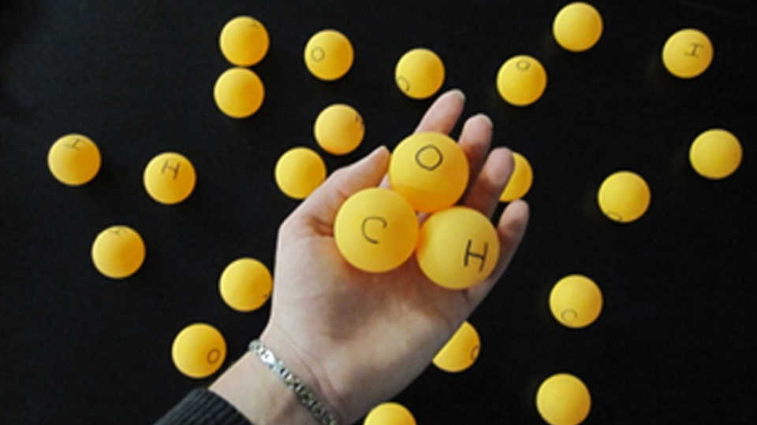  In this kinesthetic model, students will learn that plants need carbon dioxide, water, and sunlight to carry out photosynthesis. Using ping pong balls and egg cartons, they will simulate the production of sugar molecules to store energy (photosynthesis) and then break apart these molecules to acquire energy (cellular respiration). This active simulation makes it easier to remember both processes and one depends on the other!  Objectives  Through this kinesthetic model, students will learn:  - that plants need carbon dioxide, water, and sunlight to carry out photosynthesis.  - that photosynthesis produces sugar molecules that store energy.  - that plants and animals can use that energy after breaking apart the sugar molecules through cellular respiration.  - that plants exchange gases through the stomata and land vertebrates exchange gases through the lungs. | Lesson Look Fors  Look for teachers to:  - Allow students to productively struggle with the content, using accountable talk moves to facilitate the lesson.  - Teachers should be walking around the room ensuring that students are engaged in all activities correctly, consistently monitoring for incorrect biology.  Look for students to:  - Engage in the hands-on-minds-on modeling activity  - Ask clarifying questions regarding what they are learning  - Write in complete sentences  Students Do and Know
  - Analyze a model showing similarities and differences between cellular respiration and photosynthesis.
  - Create a model of two organisms working together as it relates to the two processes.
  - Write an explanation of the relationship between the two processes.
  - Energy is cycled in an ecosystem.
  - The chemical reaction for cellular respiration is essentially the one for photosynthesis backwards.
  - Plants undergo cellular respiration, as well as photosynthesis.
Materials Needed
- egg cartons (6 per group)
- ping-pong balls (36 per group)
- “energy tokens” (24 per group)
- three signs, one that says “stomata,” one that says “stem,” and one that says “lungs”
- Copies of activity

This lab takes time to gather materials and set up. Ensure materials are ordered before starting unit 3

Day 9 | Flex Day
Day 10 | Review Day
Day 11 | Administer Unit Exam 3

UNPACKED STANDARDS
Focus standards for this unit.

Standards Clarification
Standards | Specificity | Notes/Explanations/Examples
B.11.A – explain how matter is conserved, and energy is transferred during photosynthesis and cellular respiration using models, including the chemical equations for these processes | Cognition: Explain  Content: how matter is conserved during photosynthesis using models  Cognition: Explain  Content: how matter is conserved during cellular respiration using models  Cognition: Explain  Content: how energy is transferred during photosynthesis using models  Cognition: Explain  Content: how energy is transferred during cellular respiration using models  Cognition: Explain  Content: the chemical equation for photosynthesis  Cognition: Explain  Content: the chemical equation for cellular respiration  This standard supports B.5(C) by exploring how the processes of cellular respiration and photosynthesis synthesize new molecules. This standard examines the metabolic process in plants. | Animals obtain glucose from food and convert its energy to usable ATP during cellular respiration. Students may be confused by this concept because the reactants in photosynthesis are the products in cellular respiration.  When you teach this concept, remember to:  - Allow students to create models and explanations of cellular respiration in one cycle.  - Investigate the chemical equations and the energy input/output of cellular respiration.  - Guide students to discover that in cellular respiration the number of atoms on both sides of the reaction are the same (matter is conserved).  Students may make the following mistakes:  - Misinterpreting the reactants and products in the equations for cellular respiration  - Not recognizing that energy is transformed in cellular respiration  Plants make their own glucose through photosynthesis. Students may be confused by this concept because the reactants in photosynthesis are the products in cellular respiration.  When you teach this concept, remember to:  - Have students create models and explanations of photosynthesis in one cycle.  - Investigate the chemical equations and the energy input/output of photosynthesis.  - Investigate the inverse relationship of photosynthesis and cellular respiration and the importance of chlorophyll and ATP.  - Guide students to discover that in photosynthesis the number of atoms on both sides of the reaction are the same (matter is conserved).  Students may make the following mistakes:  - Misinterpreting the reactants and products in the equations for photosynthesis  - Not recognizing that energy is transformed in photosynthesis
B.11.B – investigate and explain the role of enzymes in facilitating cellular processes | Cognition: Investigate  Content: the role of enzymes in facilitating cellular processes  Cognition: Explain  Content: the role of enzymes in facilitating cellular processes  This standard supports B.5(A) because enzymes are the catalyst of biochemical reactions in the body, and the body is made up of biomolecules. | Enzymes are biological catalysts that accelerate chemical reactions by acting on molecules known as substrates. Understanding how to identify and investigate the role of enzymes further builds on the concepts of metabolic processes and energy  conversions that occur in living organisms.  When you teach this concept, remember to:  - Provide opportunities for students to describe how enzymes are important in the human body.  - Allow students to identify, investigate, model, and explain the effects of enzymes on reaction rates.  - Explore the specificity of enzyme to substrate and factors that affect enzyme activity.  - Have students use a variety of methods for illustrating the effects of enzymes and the factors that affect enzyme activity (tables, graphs, visuals).

VERTCAL STANDARDS
This section details the progression of key student expectations/standards** in the courses before and after this course. This will help you understand what prior knowledge skills to build upon and guide you in knowing what skills you are preparing your students for in the subsequent course.

Biology Standard | Connections
B.11.A – explain how matter is conserved, and energy is transferred during photosynthesis and cellular respiration using models, including the chemical equations for these processes | 4th Grade  - S.4.12.A – investigate and explain how most producers can make their own food using sunlight, water, and carbon dioxide through the cycling of matter  6th Grade  - S.6.13.A – describe the historical development of cell theory and explain how organisms are composed of one or more cells, which come from pre-existing cells and are the basic unit of structure and function  8th Grade  - S.8.13.A – identify the function of the cell membrane, cell wall, nucleus, ribosomes, cytoplasm, mitochondria, chloroplasts, and vacuoles in plant or animal cells  Biology:  - B.5.A – relate the functions of different types of biomolecules, including carbohydrates, lipids, proteins, and nucleic acids, to the structure and function of a cell  - B.5.B – compare and contrast prokaryotic and eukaryotic cells, including their complexity, and compare and contrast scientific explanations for cellular complexity  - B.5.C – investigate homeostasis through the cellular transport of molecules  - B.11.B – investigate and explain the role of enzymes in facilitating cellular processes  AP Biology  - ENE-1.I – Describe the photosynthetic processes that allow organisms to capture and store energy.  - ENE-1.J – Explain how cells capture energy from light and transfer it to biological molecules for storage and use.  - ENE-1.K – Describe the processes that allow organisms to use energy stored in biological macromolecules.  - ENE-1.L – Explain how cells obtain energy from biological macromolecules in order to power cellular functions.
B.11.B – investigate and explain the role of enzymes in facilitating cellular processes | 6th Grade  - S.6.13.A – describe the historical development of cell theory and explain how organisms are composed of one or more cells, which come from pre-existing cells and are the basic unit of structure and function  8th Grade  - S.8.13.A – identify the function of the cell membrane, cell wall, nucleus, ribosomes, cytoplasm, mitochondria, chloroplasts, and vacuoles in plant or animal cells  Biology:  - B.5.A – relate the functions of different types of biomolecules, including carbohydrates, lipids, proteins, and nucleic acids, to the structure and function of a cell  - B.5.B – compare and contrast prokaryotic and eukaryotic cells, including their complexity, and compare and contrast scientific explanations for cellular complexity  - B.5.C – investigate homeostasis through the cellular transport of molecules  - B.11.B – investigate and explain the role of enzymes in facilitating cellular processes  AP Biology  - ENE-1.D – Describe the properties of enzymes.  - ENE-1.E – Explain how enzymes affect the rate of biological reactions.  - ENE-1.F – Explain how changes to the structure of an enzyme may affect its function.  - ENE-1.G – Explain how the cellular environment affects enzyme activity.  - ENE-1.H – Describe the role of energy in living organisms.

VOCABULARY GLOSSARY
Domain-specific words and definitions for this unit.
Key Content Vocabulary
- Active site – region of an enzyme that binds to a protein or other substance during a reaction
- Aerobic Respiration – set of metabolic reactions and processes that take place in the cells of organisms to convert chemical energy from oxygen molecules or nutrients into adenosine triphosphate (ATP) and then release waste products.
- Activation Energy – the minimum amount of extra energy required by a reacting molecule to get converted into a product
- Anabolic – The series of chemical reactions that constructs or synthesizes molecules from smaller units, usually requiring input of energy (ATP) in the process.
- Anaerobic – Not requiring, or capable of occurring, in the absence of air or free oxygen.
- ATP – adenosine triphosphate
- ATP Synthase – enzyme that creates most of the ATP created in cellular respiration.
- C4 – photosynthetic process in some plants. It is the first step in extracting carbon from carbon dioxide (CO₂) to be able to use it in sugar and other biomolecules. It is one of three known processes for carbon fixation. C4 refers to the four-carbon molecule that is the first product of this type of carbon fixation.
- Calvin Cycle – the light independent reaction of photosynthesis that occur in the stroma
- Catabolism – the breakdown of complex molecules in living organisms to form simpler ones, together with the release of energy
- Catalysis – the acceleration of a chemical reaction by a catalyst
- Cellular Respiration – a metabolic pathway that uses glucose to produce adenosine triphosphate (ATP)
- Chemical reaction – The processes, in which a substance or substances undergo a chemical change to produce new substance or substances, with entire new properties
- Competitive inhibition – phenomenon in which a substrate molecule is prevented from binding to the active site of an enzyme by a molecule that is very similar in structure to the substrate.
- Non-competitive inhibition – where the inhibitor reduces the activity of the enzyme and binds equally well to the enzyme whether or not it has already bound the substrate
- Calvin cycle – A cyclical series of biochemical reactions that occur in the stroma of chloroplasts during photosynthesis. It includes the light-independent reactions such as carbon fixation, reduction reactions and ribulose 1,5-diphosphate (RuDP) whereby sugars and starch are ultimately produced.
- Chemiosmosis – refers to the process of moving ions (e.g., protons) to the other side of the membrane resulting in the generation of an electrochemical gradient that can be used to drive ATP synthesis.
- Chlorophyll – The green pigment found in the chloroplasts of higher plants and in cells of photosynthetic microorganisms (e.g., photosynthetic bacteria), which is primarily involved in absorbing light energy for photosynthesis
- Chloroplast – refers to the organelle found within the cell of plants and other photosynthetic eukaryotes that is filled with the green pigment called chlorophyll.
- coupled reactions – chemical reaction with a common intermediate in which energy is transferred from one side of the reaction to the other. An example is the formation of ATP, which is an endergonic process and is coupled to the dissipation of a proton gradient.
- Denaturation – the unfolding or breaking up of a protein, modifying its standard three-dimensional structure
- electron transport chain – A group of compounds that pass electron from one to another via redox reactions coupled with the transfer of proton across a membrane to create a proton gradient that drives ATP synthesis
- Energy – The ability to do work or produce change.
- enzyme – proteins that help speed up metabolism, or chemical reactions in our bodies.
- ethyl alcohol – grain alcohol, made from sugar, starch and other carbohydrates by fermentation
- FADH₂ – FAD acts as an oxidizing agent. One of the most crucial reactions FAD is involved with is in the citric acid cycle. Succinate dehydrogenase is an enzyme that oxidizes succinate to be converted into fumarate by coupling it with the reduction of ubiquinone to ubiquinol. The electrons from the oxidation are stored transiently by the reduction of FAD to FADH₂. FADH₂ reverts to FAD by sending two electrons through the electron transport chain.
- Fermentation – breaking down of sugar molecules into simpler compounds to produce substances that can be used in making chemical energy. Chemical energy, typically in the form of ATP, is important as it drives various biological processes. Fermentation does not use oxygen; thus, it is “anaerobic.”
- Free Energy – The energy available to do work
- Glucose – monosaccharide broken down during cellular respiration
- Glycolysis – The initial metabolic pathway of cellular respiration in which a series of reactions happening in the cytosol results in the conversion of a monosaccharide, often glucose, into pyruvate, and the concomitant production of a relatively small amount of high-energy biomolecule, such as ATP
- Kinetics – the branch of chemistry or biochemistry concerned with measuring and studying the rates of reactions
- Krebs cycle (citric acid cycle) – (1) A cycle of reactions catalyzed by enzymes in which pyruvate derived from nutrients and converted to Acetyl Coenzyme A is completely oxidized and broken down into carbon dioxide and water to produce high-energy phosphate compounds, which are the source of cellular energy. (2) One of the major metabolic pathways of cellular respiration and involves a cyclic series of enzymatic reactions by which pyruvate converted into Acetyl Coenzyme A is completely oxidized to CO2 and hydrogen is removed from the carbon molecules, transferring the hydrogen atoms and electrons to electron-carrier molecules (e.g., NADH and FADH2) as well as the metabolic energy to high energy bonds (e.g., ATP).
- lactic acid – An intermediate product of carbohydrate metabolism (anaerobic metabolism), derived chiefly from muscle cells and red blood cells.
- Light-dependent reactions – The reaction taking place in the chloroplast in which the absorption of a photon leads to the formation of ATP and NADPH.
- Light-independent reactions – See Calvin Cycle
- Mitochondria – eukaryotic organelle where cellular respiration takes place
- NAD – a coenzyme involved in redox reactions; In metabolic reactions, nicotinamide adenine dinucleotide may be oxidized, NAD+, or reduced, NADH.
- NADP – A coenzyme that serves as an electron carrier in a number of reactions, being alternately oxidized (NADP-) and reduced (NADPH).
- oxidative phosphorylation – A metabolic pathway that generates ATP from ADP through phosphorylation that derives the energy from the oxidation of nutrients
- pH – measure of the amount of hydrogen ions are in a solution
- Photolysis – The splitting or decomposition of a chemical compound by means of light energy or photons.
- Photosynthesis – The synthesis of complex organic material using carbon dioxide, water, inorganic salts, and light energy (from sunlight) captured by light-absorbing pigments, such as chlorophyll and other accessory pigments.
- Reactant – substance that takes part in and undergoes change during a reaction
- Reaction rate – the speed at which a chemical reaction takes place
- Product – end substances after a biological process has occurred
- Stroma – the “cytoplasm” of the chloroplast where the grana are located.
- Substrate – The substance acted upon by an enzyme.
- Substrate concentration – amount of the substrate that is available to be catalyzed
- Temperature – the measure of hotness or coldness expressed in terms of any of several scales, including Fahrenheit and Celsius
- Thylakoid – structure in the chloroplast where the light dependent reactions take place.
- Wavelength – the distance between identical points (adjacent crests) in the adjacent cycles of a waveform signal propagated in space or along a wire

